

Course Code: CSE-360

Course Title: Microprocessor and Microcontrollers

Project Name: Calculator For Simple Mathematical Calculation.

Submitted to:

Md. Ismail

Lecturer, UITS,

B.Sc. in CSE, RUET.

Submitted by:

Name : Adibul Asam

ID : 0432310005101025

Batch : 53rd

Section : 6(A1)

Introduction:

The purpose of this project is to design and implement a simple arithmetic calculator using 8086 Assembly Language. The calculator runs in a DOS environment and supports four basic arithmetic operations: Addition, Subtraction, Multiplication, and Division.

The project demonstrates key concepts of assembly language such as interrupt handling, user input/output operations, procedure calls, integer arithmetic instructions, register manipulation, and program control flow.

This project also helps learners understand how low-level programming interacts directly with the CPU through instructions like add, sub, imul, and idiv.

Method & Description:

The calculator program follows a menu-driven approach. The user is first shown a list of operations and is prompted to select one. Each operation is implemented with separate procedures for better modularity.

Main Components of the Program

1. Menu Display

The menu is printed using DOS interrupt INT 21h, function 09h.
The user selects an option using function 01h.

2. Input Handling

Two numbers are taken as input using the custom procedure read_number.
It handles:

Multi-digit numbers

Negative numbers

Input validation

Characters are converted to integers by subtracting '0' and constructing the number step by step.

3. Arithmetic Operations

Each arithmetic operation is performed using 8086 instructions:

Addition: add ax, num2

Subtraction: sub ax, num2

Multiplication: imul num2

Division:

cwd (sign extension)

idiv num2

Division also handles division by zero, displaying an error message.

Sample Output:

Example 1: Addition
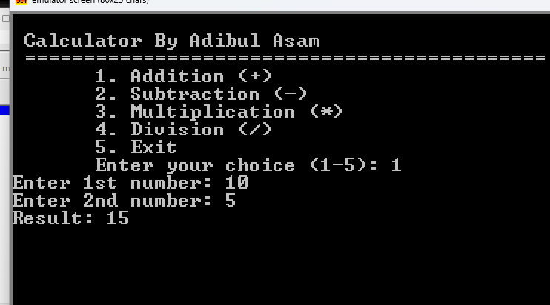

Example 2: Division
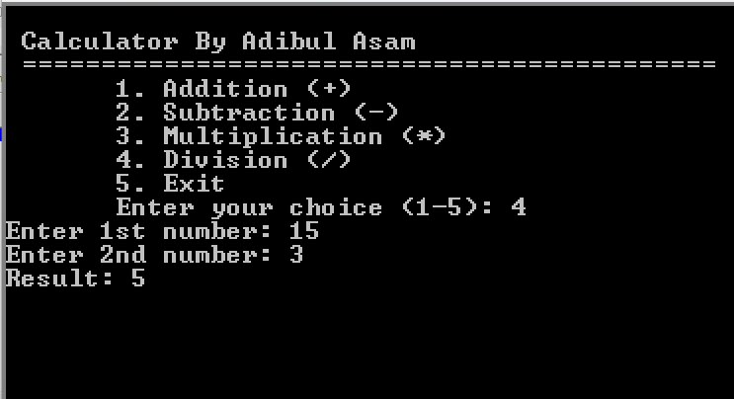

Example 3: Division By Zero
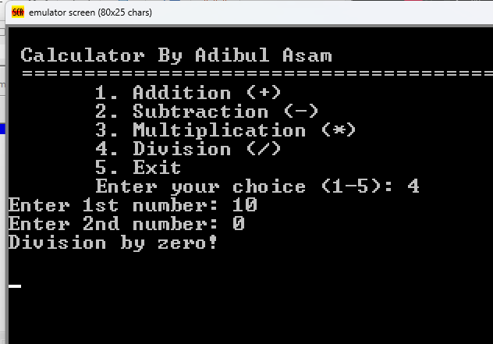

Conclusion
This project successfully demonstrates how a basic calculator can be built using 8086 Assembly Language. By implementing user input/output, arithmetic instructions, procedure handling, and error checking, this project provides a strong foundation in low-level programming concepts.
The program is efficient, modular, and interactive—showing how assembly language can control the CPU directly to perform essential computational tasks.

